**Optimizing HPV Vaccination Coverage through Targeted School Health Policies in the United States.**

*Miltone Obote Awiti, Oscar Odiwuor Odera*

**Abstract**

The Human Papillomavirus (HPV) is the most predominant among sexually transmitted diseases, with serious implications for women's health worldwide. Globally, prevalence of HPV is high in sub-Saharan Africa at 24%, with Latin America and the Caribbean at 16% and Eastern Europe at 14%. Even with the availability of effective vaccines, the rate of HPV vaccination remains a challenge among young school-aged girls in the United States, pointing to the need for specialized and targeted public health strategies. This study aims to explore the efficacy of specialized school health policies in realizing HPV vaccination coverage among school-aged girls of 11-25 years. Through analysis of current vaccination strategies and identifying obstacles to vaccine uptake, the study aims to propose enhanced policy to increase coverage rates, particularly by reviewing existing data from HPV vaccination and recommending appropriate policies to optimize the coverage. The study will scrutinize quantitative data from peer-reviewed literature, data from Advisory Committee on Immunization Practices, and various case studies on HPV vaccination programs in high and middle-income states in the US. The study will involve evaluating the impact of various factors like educational efforts, policy frameworks and vaccine accessibility, on the acceptance and uptake of the vaccination. Preliminary findings suggest that states with HPV school vaccination policies e.g. Rhode Island, Virginia and D.C have done considerably well in optimizing vaccination coverage with Rhode Island leading the park at 85.2% of adolescent girls having received HPV vaccines. On the other hand, Mississippi is the lowest at 38.5% on HPV adolescent vaccination. Optimizing HPV vaccination coverage will require a different approach that goes beyond traditional health policy models, hence, this study will examine existing data from HPV school vaccination and policies then recommend reforms that prioritize public health sensitization, vaccine accessibility, and community involvement to achieve universal HPV vaccination coverage for school-aged girls.

**Introduction**

HPV vaccination rates have consistently fallen behind those of other adolescent vaccines, exacerbated by disruptions in routine childhood vaccine delivery caused by the coronavirus disease pandemic. Efforts to bolster HPV vaccination coverage in schools have involved implementing evidence-based practices and interventions, including provider education, incentives, school outreach, and employing multidisciplinary approaches.

However, current interventions yield only marginal increases in vaccination coverage and necessitate frequent reinforcement. To address this challenge effectively, additional multi-faceted approaches pertaining to HPV vaccine access and uptake are necessary. Potential strategies encompass HPV vaccination mandates for school entry, expanding adolescent consent for vaccination, and facilitating pharmacist-administered vaccination.

For HPV-related policies to succeed, various conditions must be met, including adequate vaccine coverage and funding through programs like the Vaccines for Children (VFC) initiative, public acceptance of vaccine efficacy and safety, incorporation of the vaccine into immunization information systems, and endorsement from physicians/providers, alongside potential vaccine mandates.

Nonetheless, a comprehensive evaluation of vaccine mandates is crucial, considering diverse factors such as epidemiological, economic, and ethical considerations. Careful implementation is essential to prevent undermining support for immunization programs and to uphold the progress achieved through existing policies and initiatives.

**Literature Review**

Human Papilloma Virus is an emerging sexually transmitted infection that has important consequences for public health due its association to cervical cancer in women and other associated illnesses. Even with the existence of effective vaccines, reaching admired vaccination rates is still challenging, particularly for school-aged American girls. This study emphasizes on investigating prior research regarding the impact of various school health policies on optimizing HPV vaccination rates in school girls aged 11-25 years.

1. **Human Papillomavirus Vaccination USA Case Scenario**.

The arrival of HPV vaccines marked a major advancement in preventive healthcare. Yet, vaccination rates in the United States have consistently failed to meet national goals. Different research has found obstacles to getting the HPV vaccine, such as worries about safety and effectiveness among parents, healthcare providers not recommending it, and difficulties in accessing and administering the vaccine.

1. **Impact of Targeted Policies on Vaccination Rates.**

Research probing the effects of specific school health policies on HPV vaccination coverage has shown mixed results. Some reports show that school-based vaccination programs can escalate vaccine acceptance rates, but other studies suggest that the impact of these strategies can be different based on factors like income, locality as well as parental concerns on vaccination.

1. **Role of School Health Policies in Vaccination Coverage.**

School health policies are critical for providing vaccines to adolescents, as schools are target locations for delivering healthcare services due ease of access and centralization. A number of States like Rhode Island and DC have introduced school-based HPV immunization initiatives, which either require vaccination or offer chances for vaccination at schools. These policies target problems related to convenience and parental knowledge by integration or routinizing HPV vaccination into regular healthcare services.

1. **Strategies for Enhancing Policy Effectiveness.**

Various interventions have been put forth by researchers and policymakers to improve HPV vaccination coverage through targeted school health policies. These consist of establishing rapid-result vaccination programs in schools, improving parental communication and education, tackling vaccine rumor tracking with evidence-based messaging, and guaranteeing vaccines equity to disadvantaged populations.

1. **Future Directions and Recommendations.**

Going forward, it is important to keep evaluating the effectiveness of targeted school health policies in optimizing HPV vaccination coverage. Future studies need to focus on finding the most effective procedures and filling in the gaps in policy formulation and implementation to enhance the effectiveness of HPV vaccines in preventing cervical cancer. Furthermore, it is crucial for public health agencies, schools, healthcare providers and community stakeholders to work together in order to forge comprehensive and long-lasting policies for enhancing HPV vaccination.

**Conclusion.**

To sum up, targeted school health policies can greatly improve HPV vaccination rates among American adolescents and young adults. These policies can influence the uptake of vaccines and help avert HPV-related diseases by overcoming hindrances to access and incorporating the school system's infrastructure. However, continuous studies and collaborations are essential to guarantee that these efforts are effectively promoting population health and are decreasing the impact of HPV infection and related diseases.

6. **Review of existing documents**

**7. Results**

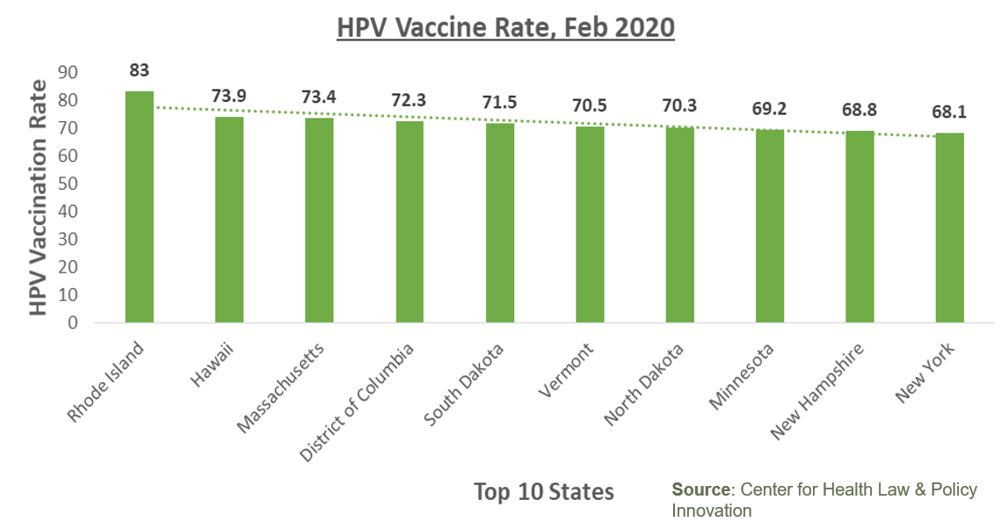

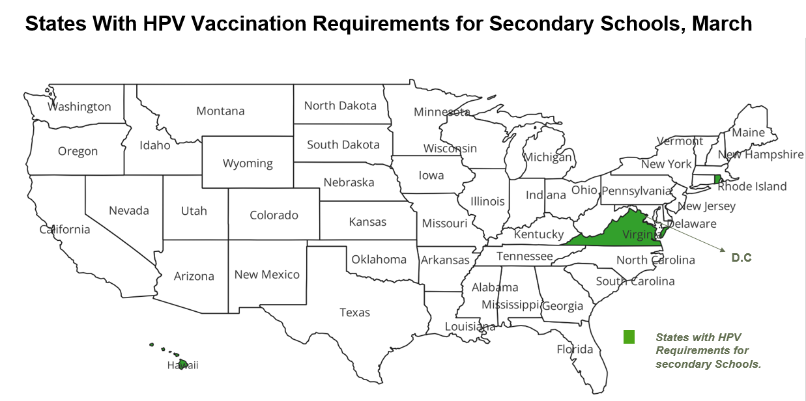

**8. Impacts on population**

**1. Health Impact**

Low HPV vaccination rates contribute to increased vulnerability to HPV-related diseases, including certain types of cancers. Improving vaccination coverage can significantly reduce the incidence of these diseases, leading to better health outcomes for the population.

**2. Economic Impact**

HPV-related diseases impose substantial economic burdens on healthcare systems and individuals. Increased vaccination coverage can alleviate some of these burdens by reducing the need for costly treatments and medical interventions associated with HPV-related conditions.

**3. Educational Impact**

Mandating HPV vaccination for school entry can ensure that adolescents receive necessary vaccinations, contributing to a healthier school environment. However, implementation may face resistance from certain segments of the population, necessitating education and outreach efforts to address concerns and promote acceptance.

**4. Social Impact/Safety net**

Improved HPV vaccination rates can have broader social benefits by reducing the transmission of HPV infections within communities. This can contribute to overall public health and well-being by preventing the spread of infectious diseases.

**5. Equity Impact**

Efforts to increase HPV vaccination rates should also consider equity implications, ensuring that all segments of the population have access to vaccination services. Addressing barriers to vaccination, such as cost, accessibility, and awareness, can help reduce disparities in HPV-related disease burden among different demographic groups.

**6. Long-Term Impact**

By increasing HPV vaccination rates and implementing comprehensive strategies, such as vaccine mandates and provider education, the population can experience long-term benefits in terms of reduced HPV-related disease burden, improved public health outcomes, and potentially lower healthcare costs over time.

**Challenges**

1. ***Parental Consent Requirements***- Many states require parental consent for vaccination, which can be a barrier if parents are unaware of the importance of HPV vaccination or hold misconceptions about its safety and efficacy.

2. ***Lack of Education and Awareness***- There may be a lack of education and awareness among parents, students, and even healthcare providers about the importance of HPV vaccination in preventing certain types of cancers.

3. ***Stigma and Misinformation***- HPV vaccination has faced stigma and misinformation regarding its safety and association with sexual activity. Addressing these misconceptions is crucial in increasing vaccination rates.

4. ***Healthcare Access and Equity***- Disparities in healthcare access and availability of vaccination services can lead to unequal vaccination rates across different demographic groups, exacerbating health inequities.

5. ***Opt-out Provision***s- Some states allow parents to opt their children out of school vaccination requirements for personal or philosophical reasons, which can undermine efforts to achieve high vaccination coverage rates.

**Related work conducted by others**

**1."Increasing HPV vaccination coverage through provider-based interventions"** by Gilkey et al. This study explores the effectiveness of provider-based interventions, such as reminders and recalls, in improving HPV vaccination rates among adolescents. It compares different strategies and their impact on vaccination coverage.

**2."The role of school-based health centers in promoting HPV vaccination: A systematic review"** by Patel et al. This systematic review evaluates the effectiveness of school-based health centers in promoting HPV vaccination uptake. It synthesizes evidence from various studies to assess the impact of different interventions implemented in school settings.

**3. "Using GIS mapping to target public health interventions: Examining disparities in HPV vaccination coverage among adolescents in the United States"** by Smith et al. This study utilizes Geographic Information Systems (GIS) mapping to identify geographical areas with low HPV vaccination coverage among adolescents. It highlights the potential of targeted interventions in addressing disparities in vaccination uptake.

**Opportunities**

1. **Policy Evaluation**: There's an opportunity to evaluate existing school health policies related to HPV vaccination and assess their effectiveness. This evaluation can identify gaps in policy implementation, barriers to vaccination, and areas for improvement.
2. **Technology Integration**: Leveraging technology, such as mobile apps, telemedicine, and electronic health records, can improve communication, streamline vaccine delivery, and facilitate tracking of vaccination rates. There's an opportunity to explore how technology can be integrated into school health policies to enhance HPV vaccination efforts.
3. **Addressing Equity:** Research can focus on addressing disparities in HPV vaccination coverage among different demographic groups, including racial/ethnic minorities, low-income populations, and rural communities. Understanding the underlying factors contributing to these disparities and developing targeted interventions to address them is crucial.
4. **School-Based Health Centers (SBHCs)**: SBHCs play a vital role in providing healthcare services to students, including HPV vaccination. There's an opportunity to strengthen the capacity of SBHCs to deliver HPV vaccines effectively, improve access to care, and integrate vaccination efforts into broader school health initiatives.
5. **Parent and Community Engagement**: Engaging parents, caregivers, and community members is essential for increasing HPV vaccination acceptance and uptake. Research can explore effective strategies for engaging these stakeholders, addressing concerns and misconceptions, and promoting vaccine acceptance within communities.

**Conclusion**

Targeted school health policies can greatly improve HPV vaccination rates among adolescents and young adults. These policies can influence the uptake of vaccines and help avert HPV-related diseases by overcoming hindrances to access and incorporating the school system's infrastructure. However, continuous studies and collaborations are essential to guarantee that these efforts are effectively promoting population health and are decreasing the impact of HPV infection and related diseases.

**Recommendation**

1. Enactment of a nationwide policy that mandates schools to have HPV vaccination requirement during admission.

* The Federal government should allocate a substantial amount of funding to facilitate HPV vaccine manufacturing and distribution to schools.
* Conducting campaigns targeted at students, parents and educator to increase awareness of the impacts of HPV vaccination and addressing myths and misconceptions about the vaccine.

**References**

Shin MB, Sloan K, Baezconde-Garbanati L, Dang E, Garcia S, Palinkas LA, Unger JB, Willgerodt M, Crabtree BF, Tsui J. Multilevel perspectives on school-based opportunities to improve HPV vaccination among medically underserved adolescents: Beyond school entry mandates. Hum Vaccin Immunother. 2023 Aug 1;19(2):2251815. doi: 10.1080/21645515.2023.2251815. PMID: 37666253; PMCID: PMC10478734.

Kaul S, Do TQN, Hsu E, Schmeler KM, Montealegre JR, Rodriguez AM. School-based human papillomavirus vaccination program for increasing vaccine uptake in an underserved area in Texas. Papillomavirus Res. 2019 Dec;8:100189. doi: 10.1016/j.pvr.2019.100189. Epub 2019 Oct 22. PMID: 31654772; PMCID: PMC6838925.

Stewart A. Childhood vaccine and school entry laws: the case of HPV vaccine. Public Health Rep. 2008 Nov-Dec;123(6):801-3. doi: 10.1177/003335490812300617. PMID: 19711662; PMCID: PMC2556726.

Lehmann, C.E. *et al.* (2016) ‘Adolescent Vaccination Strategies: Interventions to Increase Coverage’, *Pediatric Drugs*, 18(4), pp. 273–285. Available at: https://doi.org/10.1007/s40272-016-0177-1.

‌‘Strengthening the Effectiveness of National, State, and Local Efforts to Improve HPV Vaccination Coverage in the United States: Recommendations From the National Vaccine Advisory Committee’ (2018) *Public Health Reports*, 133(5), pp. 543–550. Available at: https://doi.org/10.1177/0033354918793629.

*AIM Position Statement on School and Child Care Immunization Requirements* (2006) *Association of Immunization Managers*. Available at: https://www.immunizationmanagers.org/resources/aim-position-on-school-requirements/ (Accessed: 18 April 2024).

*Pharmacists as Immunizers* (no date) *www.health.ny.gov*. Available at: https://www.health.ny.gov/prevention/immunization/providers/pharmacists_as_immunizers.htm.